Class 5 – Global Energy Transition

Instructor: Nate Tucker

Date: 27-Feb-2021



# Course Overview:

* 5 Saturday Meetings - Discussion oriented
  + Intro to Energy
  + Conventional Energy Sources (coal, natural gas, petroleum)
  + Renewable Energy Sources (solar, wind, geothermal, hydro)
  + Upcoming Technologies, Future Goals, Industry Shifts
  + Review, Sustainability in our lives

# Review Classes 1,2,3,4

* What we learned from class 1:
  + Many types of energy
  + Our society is inefficient, we waste a lot of energy
  + “Sustainable” technologies depend on their energy source
  + Articles about energy can be biased
* What we learned from class 2:
  + Limited supply of coal and oil in the world
  + Coal and oil are transported across the world for use
  + Oil can have some negative effects on the environment if not handled correctly
  + Coal and oil have been used as energy resources for a long time
  + Coal – mainly used for generating electricity (steam plant)
  + Oil – mainly used for transportation (i.e., refined into gasoline, diesel, etc.)
* What we learned from class 3:
  + Learned about solar towers that use mirrors to reflect sunlight to heat up molten salt to create steam
  + Learned about wind, solar, hydro, and geothermal renewable energy resources
  + Learned there are pros and cons to each renewable energy source
* What we learned from class 4:
  + Basics of CO2 emissions, greenhouse gases, and global climate change
  + Global temperature trends and potential effects
  + What humanity can do to curb our C02 emissions (8 wedges)

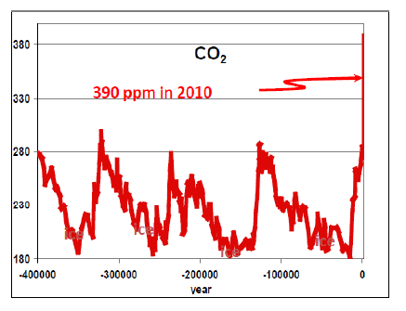

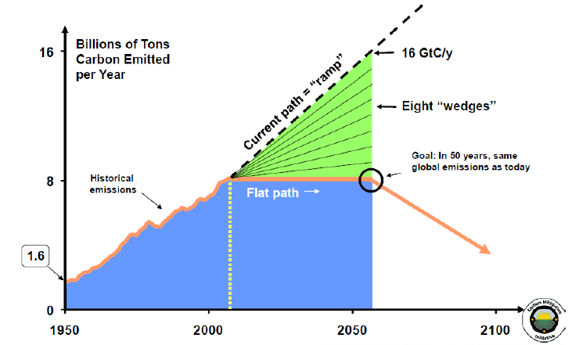

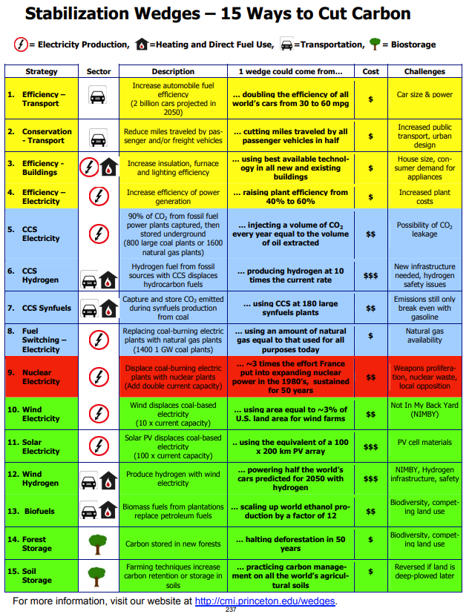

# Energy Conservation and Energy Efficiency

* Energy Conservation
  + “Not wasting energy”
  + Changing one’s behavior (e.g., taking shorter showers)
* Energy Efficiency
  + How much of a given amount of energy can be converted from one form to another useful form
  + In practical applications, energy efficiency means producing a desired result using as little energy as possible
* Turning off a light – conserves energy
* Using a compact fluorescent bulb instead of an incandescent bulb – using energy efficiently

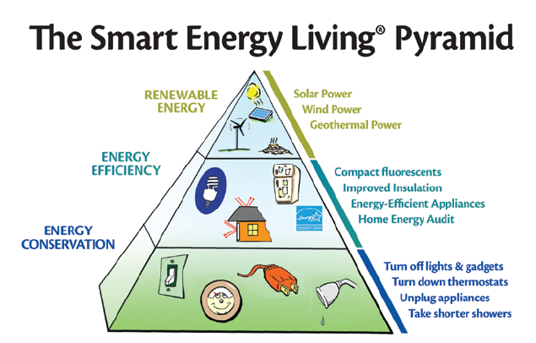

* Base of the pyramid – energy conservation
  + Suggests that it is better to change behavior to conserve energy rather than investing money to become more energy efficient
  + It’s the quickest and least expensive way to save energy
* Energy efficiency is next
  + Medium cost, immediate results
  + Example: Sustainable buildings
    - Whole building is designed for energy efficiency
    - Passive and active systems to reduce energy usage
    - Example: more insulation (passive) to keep a building warm in winter reduces the need to use a furnace (active)

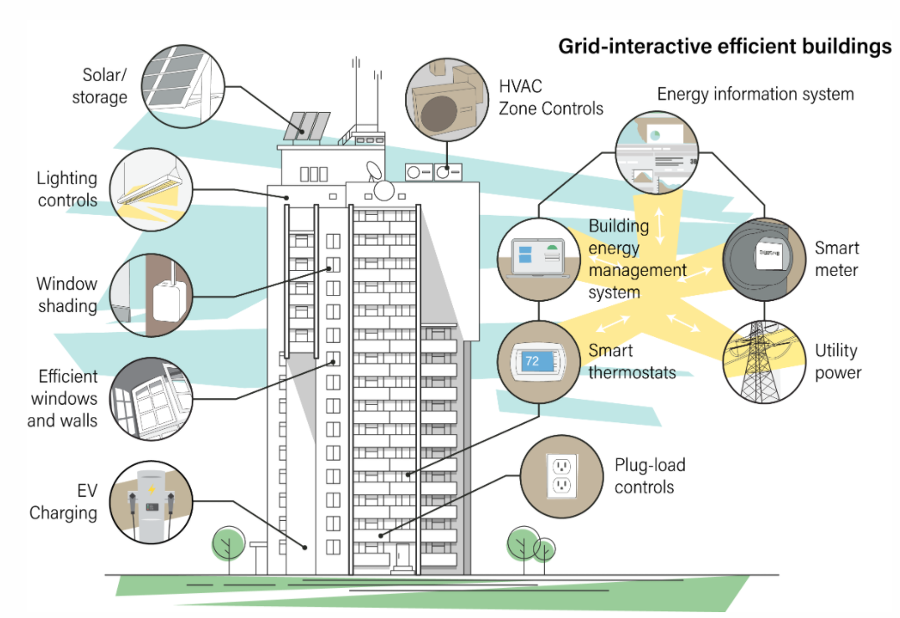

* Top of the pyramid – renewable energy generation
  + Biggest investment, should optimize cheaper options first

# Lighting

* Accounts for a significant portion of the electricity used in the United States
* In schools, about 30% of the total electricity bill is lighting
* In homes, about 10% of the total electricity bill is lighting
* Recent developments in Compact Fluorescent Bulbs (CFLs) have resulted in bulbs that are 4x as efficient as incandescent bults and last up to 13x longer
* U.S. government is mandating that new bulbs are energy efficient (i.e., cannot buy old bulbs anymore)

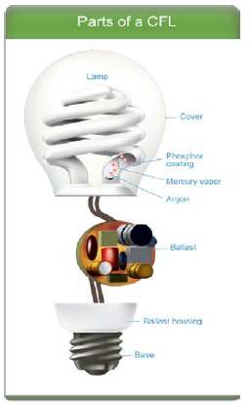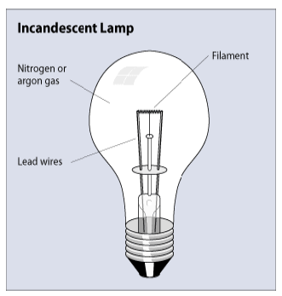

# Insulation and Heat Transfer

* Insulation provides a resistance to heat flow
* Properly insulating decreases heat flow by providing an effective resistance to the flow of heat
* Insulation’s resistance to heat flow is measured or rated in terms of its thermal resistance or R-value
  + Higher the R-value, the greater the insulating effectiveness
  + Amount of insulation or R-value you’ll need depends on your climate, type of heating and cooling system, and the section of the house/building you plan to insulate

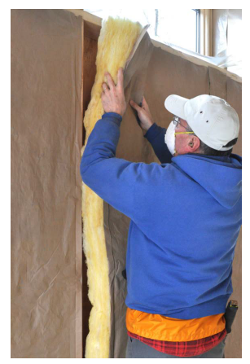

# Energy Audits

* Other ways besides lighting and insulation
  + Plugging air leaks
  + Lowering the idle temperature on your water heater
  + Cleaning furnace filters
  + Using a thermostat to control temperatures in rooms that are unoccupied
  + Purchasing new efficient appliances when older ones break
* Can perform an energy audit to save money and energy
  + Can do it yourself (home)
  + Can hire a specialist (large building)
  + <https://www.energy.gov/energysaver/home-energy-audits/do-it-yourself-home-energy-audits>

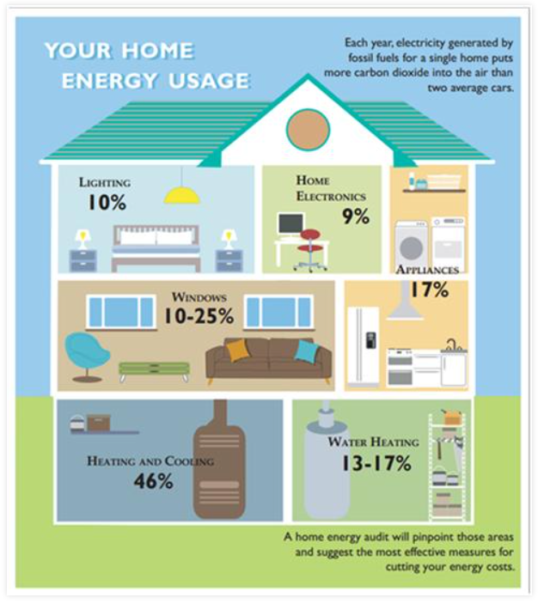

# Exit Survey ~10 minutes

<https://ucsbeducation.az1.qualtrics.com/jfe/form/SV_8fe3z7UaU1yssqp>